STUDENT REGISTRATION FORM

PROGRAM:

<html>

<head>

<script type="text/javascript" src="validate.js"></script>

</head>

<body>

<form action="#" name="StudentRegistration" onsubmit="return(validate());">

<table cellpadding="2" width="20%" bgcolor="99FFFF" align="center"

cellspacing="2">

<tr>

<td colspan=2>

<center><font size=4><b>Student Registration Form</b></font></center>

</td>

</tr>

<tr>

<td>Name</td>

<td><input type=text name=textnames id="textname" size="30"></td>

</tr>

<tr>

<td>Father Name</td>

<td><input type="text" name="fathername" id="fathername"

size="30"></td>

</tr>

<tr>

<td>Postal Address</td>

<td><input type="text" name="paddress" id="paddress" size="30"></td>

</tr>

<tr>

<td>Personal Address</td>

<td><input type="text" name="personaladdress"

id="personaladdress" size="30"></td>

</tr>

<tr>

<td>Sex</td>

<td><input type="radio" name="sex" value="male" size="10">Male

<input type="radio" name="sex" value="Female" size="10">Female</td>

</tr>

<tr>

<td>City</td>

<td><select name="City">

<option value="-1" selected>select..</option>

<option value="New Delhi">NEW DELHI</option>

<option value="Mumbai">MUMBAI</option>

<option value="Goa">GOA</option>

<option value="Patna">PATNA</option>

</select></td>

</tr>

<tr>

<td>Course</td>

<td><select name="Course">

<option value="-1" selected>select..</option>

<option value="B.Tech">B.TECH</option>

<option value="MCA">MCA</option>

<option value="MBA">MBA</option>

<option value="BCA">BCA</option>

</select></td>

</tr>

<tr>

<td>District</td>

<td><select name="District">

<option value="-1" selected>select..</option>

<option value="Nalanda">NALANDA</option>

<option value="UP">UP</option>

<option value="Goa">GOA</option>

<option value="Patna">PATNA</option>

</select></td>

</tr>

<tr>

<td>State</td>

<td><select Name="State">

<option value="-1" selected>select..</option>

<option value="New Delhi">NEW DELHI</option>

<option value="Mumbai">MUMBAI</option>

<option value="Goa">GOA</option>

<option value="Bihar">BIHAR</option>

</select></td>

</tr>

<tr>

<td>PinCode</td>

<td><input type="text" name="pincode" id="pincode" size="30"></td>

</tr>

<tr>

<td>EmailId</td>

<td><input type="text" name="emailid" id="emailid" size="30"></td>

</tr>

<tr>

<td>DOB</td>

<td><input type="text" name="dob" id="dob" size="30"></td>

</tr>

<tr>

<td>MobileNo</td>

<td><input type="text" name="mobileno" id="mobileno" size="30"></td>

</tr>

<tr>

<td><input type="reset"></td>

<td colspan="2"></td>

</tr>

</table>

<button type="button" onclick>submit here <align ="center"></button>

</form>

</body>

OUTPUT:

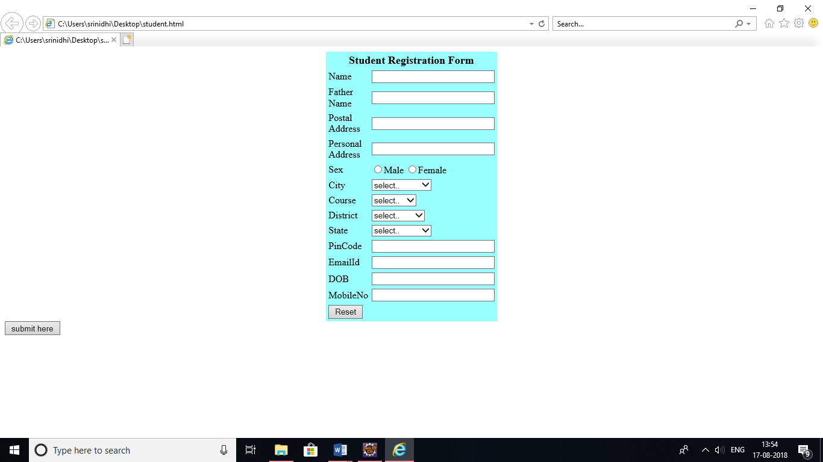

STUDENT DETAILS FILLED FORM:

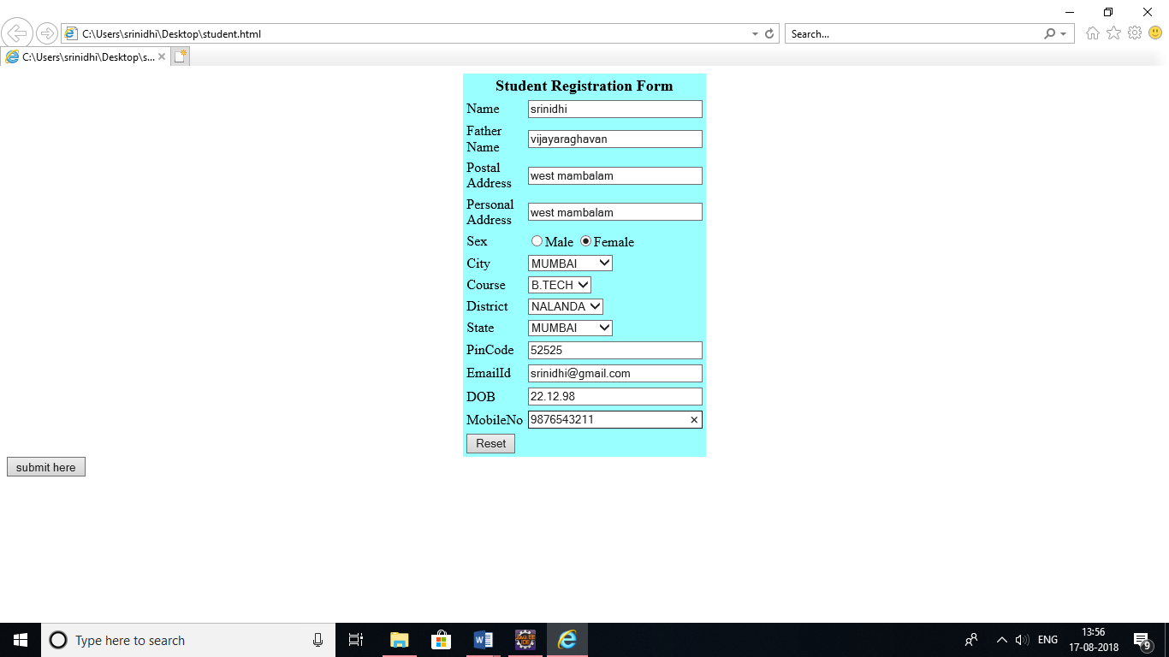

RESULT: Thus a student registration form is set up to enter the details and to genereate it and thus the program using html,css,javascript is excecuted succussfillyand the form is generated.